# University of Toronto Students: Academic vs Social Life

High-Fidelity Prototype

Unique Corns

CSC318H1

Fanny Chevalier and Khai Truong

### 

Parth Champaneri, Allen Hsiao, Clare Kim, Pascal Queeney, Patrick Tan

Monday, November 26th 2018

## Table of Contents

**University of Toronto Students: Academic vs Social Life**

Table of Contents 1

High Fidelity 2

Notes 2

Evaluation Protocol 3

Metrics 4

Instruments 4

Target Participants 4

Tasks 5

Results 8

Discussion/Implications 14

Challenges 14

Feedback 15

Dislikes 15

Successes 16

Future Improvements 16

Critique 18

Who Did What? 20

## **High Fidelity**

You can find the high fidelity prototype at:

<https://6gjdvp.axshare.com/login.html>

### **Notes**

The prototype is best used through a desktop browser, but will lose the “realism” interactivity of a mobile application. The prototype may be tested on the phone by clicking the link in a mobile browser, but note scaling may be off on different devices (Alerts may appear outside of users’ view).

Input fields were given soft cases to only check if there is content within the area, so inputs will not be dynamically be updated. On the same note, any native options like; photo upload or schedule upload, are statically made and will not be an actual prompt.

Events, and calendar dates are statically set within the prototype and can not be dynamically changed. The prototype has 4 available events a user could “potentially join” and can potentially create one event. The user will also be allowed to switch between 2 different dates in the calendar view, with predefined events listed (This is to show the possibilities of what it would look like).

## 

## **Evaluation Protocol**

For our high fidelity usability testing, we wanted to make sure that our product reflects the core theme of CHI 2019.

“In the Student Design Competition, we encourage you to contribute to this theme by considering the ways that technology might be used to **strengthen our social fabric**”

So whilst creating the protocol for the usability testing, we looked to test the key functions in our application that embraced the theme of “strengthening the social fabric”. For this testing, our protocol was structured by;

1. Introduction
2. Brief demo of the application
3. User Tasks
4. User Feedback - System Usability Scale

With this testing we want to know if students feel comfortable with finding events or creating events. We want to assure that our application is usable for each type of student because this is the goal of the theme. We hopefully want to see our application be a successful platform that helps transition the students to events of their interest. Remembering the goal of connecting students together, we look to make it comfortable for every user.

### **Metrics**

For the usability testings, we used 3 metrics to help analyze the data after.

1. Amount of time spent
2. Number of erroneous taps
3. Note difficulties

The important metric we are measuring are the difficulties that the user run into. Whether they become stuck, confused, or just unsure. Watching these reactions are important for our testing because at the end of the day, the product is to help build relationships between the student network. Understanding and noting difficulties will prevent our product in delivering, and it is important to know where each of those cases happen.

### **Instruments**

For later analyzation of our testings, we used 4 instruments;

1. Stopwatch
2. Phone
3. Laptop (If the phone prototype did not work)
4. Note pads

### **Target Participants**

Our target participants for our testings are University of Toronto Students. Our application is made to help students find academic and social events, whilst balancing their school schedule.

### **Tasks**

Each participants perform three separate tasks to cover the three basic functions served by the application. The three tasks include accessing personal profile, finding events, and creating events. Each task included a set of instructions, that included 6 separate steps, when starting each task the participant are given the instructions to read off of, while being timed by a stopwatch.

The first task involves the participant to access his or her profile. This includes looking at the profile page, and look at the participant’s personal calendar. This task is to reflect our original problem statement. The calendar functionality for the application is mainly implemented because our main problem statement is to try to solve the problem between social life and academic life. This task lets participants to try out this function, and see if the calendar system is intuitive, and useful for student life. Profiles are also kept minimalistic, but we included badge systems and threads. Badges used as achievements to incentivize students to use this application to find and create events. Threads also reflect our problem statement. We wanted threads to be a tool to help students find areas of interest, and connect with other students with the same interest. It also helps narrow down interests, and make it easier to find events. The profile page is kept minimalistic because we did not want it to be another social media application. The application should focus on events, since that is our main problem statement.

Task 1 Profile + Subscribing:

1. Login using an account (for the purpose of this test use a random email and password).
2. Import and update your current schedule, look at the schedule.
3. Go into your profile and look at the threads you are subscribed to.
4. Look for a new thread called “compsci” and subscribe to it.
5. Find events that share the same “compsci” thread.
6. Return to your profile, look at the badges.

The second task involves the participant to search for and join events. This task is the main function of our app, to let students find events throughout campus. We wanted to see whether people had a preference between map and list view on events, and if either method works better in certain situation. This task also involves the participant to test out the conflict function. The application will show conflicts from event with the student’s personal schedule. This again is trying to address the balancing between social life and academic life.

Task 2 Finding + Joining Events:

1. Look for events to join in the map view, find an sport event and read its description.
2. Go into the list view option to look at events available
3. Search for events in the compsci thread.
4. Read the description for “CSC309 review session”
5. Join the event called “CSC309 review session”
6. Try joining an event that conflict with your schedule.

The last task is mainly for students who want to create events. We wanted to test this functionality as well, despite the task not being our original problem statement. This user pretends to host a new event, and type in the name, description and location for the event. The event is published. Events are sorted by threads, and can be searched using threads. Students are able to both join as well as create their own events using the same account.

Task 3 Creating Events:

1. Look for the page to create new events.
2. Type in the name, description, location and time for the event.
3. Type in the appropriate threads that applies to the event.
4. Publish the event.
5. Try to edit the event that you have created.
6. Look at the updates presented when searching for this event.

## **Results**

Although, we have a small sample pool of participants. We were able to get a good sense of information from the 6 users. The 6 students varied across which year of schooling they are, which helped diversify the overall testings. With these testings, we got to understand similar patterns between the participants and locate different pain points and successes. We took account for the smaller sample size, and understood that a larger participant pool would help refine pain points in the prototype.

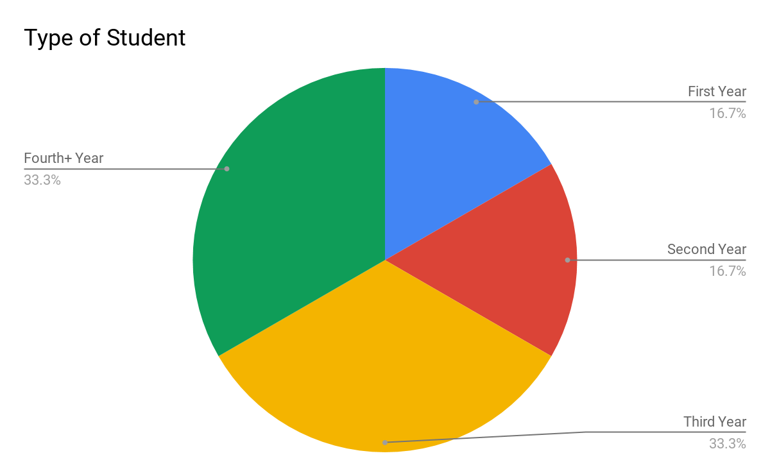

*Note: The number listed in the Legend are each SUS’ Questions.*

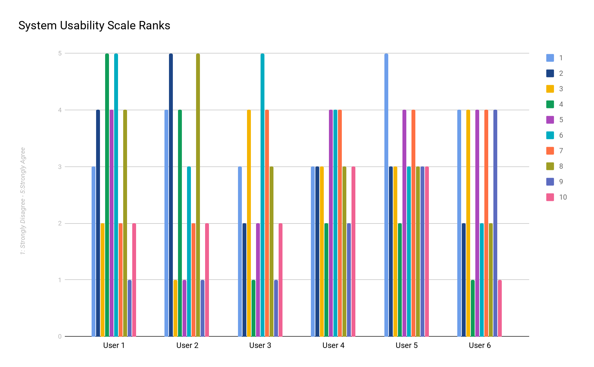

We found that commonly between each user, they were not as confident as we anticipated. Although we believe some of the confidence may be because of different challenges that were present with our Prototype via Axure. Though small details/functionality that would affect the overall user experience. But, on the positive side of the testing, we were able to find that most of the users could see themselves using the system and generally learn quickly through experience.Questions 2, 8, and 10 would help us refine pain points and making our interface simple and intuitive for every user. In which, the scale helped us further improve our product, by pointing out particular pain points.

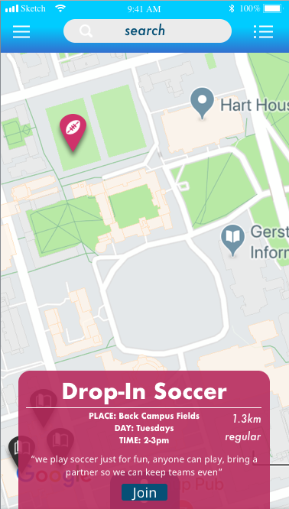

The common note from our participants on this view was the difficulty to move from a quick peek to a detailed view. Users found it frustrating that they were not able to go from the quick peek into a detailed view of the event they chose. Then secondly, it was mentioned that the search functionality needs to have a filter system. This was noted from every participant and we have learned it takes away a lot of the user’s freedom in finding events.

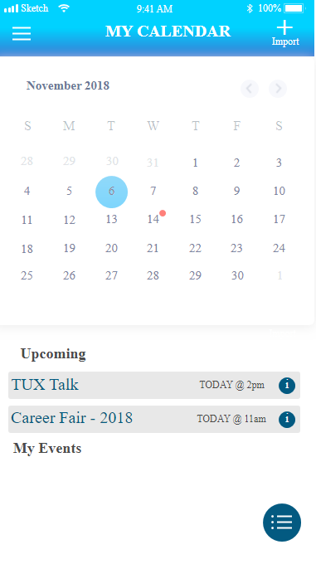

User generally liked the idea of being able to control which type of calendar they want to view. The only recurring note was the distinguishment between events. It was commonly noted that every event tab looked far too similar to one another, and it should be distinguished else wise. Which could explain the lower confident rank in our SUS because difficulty to differentiate would not make the user confident in the interaction.

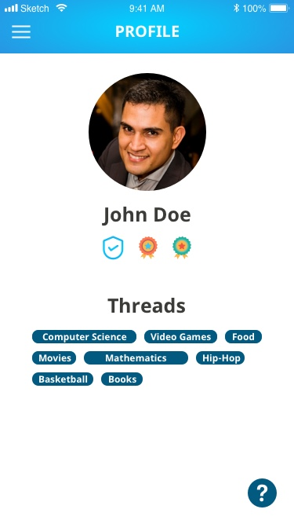

It was noted that our profile page needs revamping, pain points included; managing Threads, badges, and edit. A common trend between our participants noted that managing threads were difficult, not being able to quickly unfavourite or subscribe to. Badges were also noted to be useless, with no motivation to actually acquire them because users were not able to manage or view their badges earned. Users also found that profile should have more editing options, so they can learn more about classmates and make it easier to connect to new classmates.

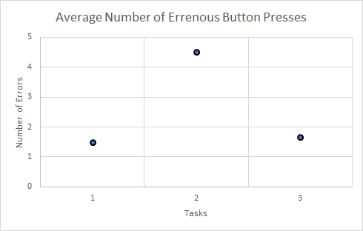

[Graph for average number of errors for each task]

(standard deviation: Task 1 = 2.07, Task 2 = 1.87, Task 3 = 1.86)

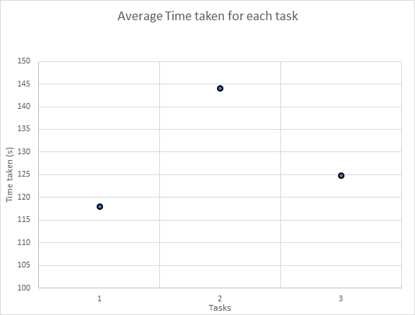

[Graph of time taken for each task]

(standard deviation: Task 1 = 9.49, Task 2 = 30.97, Task 3 = 22.47)

## **Discussion/Implications**

### **Challenges**

Prior to conducting the usability testings. We found challenges in creating the high fidelity prototype with the program Axure RP. With Axure, we found problems lying in the responsiveness (scaling) and case creating of the prototype. The scaling was probably the biggest challenge we ran into because it affected how users’ would of interacted with the prototype. The scaling issues were like; the application not completely taking the full screen (making the users scroll), toast and alerts would appear outside the view of the user on mobile and text scaling would be larger on smaller screens. These issues would have affected the overall user experience when testing our prototype, which we took into consideration.

Secondly, even though Axure has advance features for prototyping. We found that the prototype was still a little to static and not as dynamic as we intended. Although the interactivity within the application was fully functional, things like events, threads and badges were static and not interchangeable. Because of the settings of Axure, it was tedious to repeat and hit every edge case in the prototype, which caused some of stagnancy within the prototype. Setting these cases were very influential on the experience of the prototype because it would dictate where the interactions would lead to, which was reflected in some of the results.

### **Feedback**

#### **Dislikes**

There are several different problems from different users that emerged from our testing. Firstly, some functionalities were not yet implemented due to the limitations of the prototype as mentioned above, therefore sometimes erroneous taps and delays were caused by confusions due to implementation.

One of the biggest issue during our testing was the confusion with “threads”. Threads was not clearly explained in the beginning, which caused people to question what the feature was for. Threads is originally used as a subscription option to group different categories or types of events using hashtags, and allow students to see each other’s interests. This function was not clearly reflected in our prototype, and therefore we cannot conclude whether this addition is good or bad for our product.

Badges also seemed irrelevant within our testings. The badges were non-interactable, and seemed to just be decoration for the interface. There is no evidence from our testing that the badges encouraged users to use this application and let users actively seek out more events.

Although map view was originally thought as a good idea to let students see location based events, it also limited users in seeing events in detail, and makes it difficult to find specific events. Therefore we would need to reconsider the difference between list and map view, and perhaps separate them further and make it so that each search function corresponds with looking for certain events. Perhaps map view should only show events that are happening currently, or at a certain time, but listview will list out all of the events. We would need to make more testing to see which events are more effectively found using the two different searches.

#### **Successes**

Overall the navigation between the different screen is very intuitive for users. Most users do not have any problems when switching between menus and switching between types of searches. Not a lot of the mistakes came from going between different screens. Users also reveal that they do not have problems with understanding the functions, and what the application is used for.

The functionalities and feedbacks that do work worked well. Feedbacks are provided if conflicts are introduced to the schedule. Joining events and creating events is easy and very intuitive. Overall, the users understood the purpose of the application, and how events are made. Users also understood how events are being viewed and the difference between listview and map view. The map view allowed users to take a quick peek at events, while the list view allowed for a detail view. The events can also be expanded to reveal more detail about the events. There are many different screens where users can join an event, therefore it was not difficult for users to join events.

### **Future Improvements**

Where do we go from the usability testings? Our biggest goal would be to refine the suggestions we have received from the testings, into a real-time working product that is eligible for release. Putting priority in creating a product as close to production would be important for further research that could be under consideration. With a refined product we could look into “How it runs against competitors in the field (Facebook Events, Eventbrite, Meetups), or we can use it to help measure social life of students in other universities and colleges.

Some other additions that may be beneficial to improving the application are features that revolve around the “social media” aspect of the app. Although, our app is a platform to connect students, it lacks in interactivity between students and further connecting them between each other. So, in consideration we could look into developing a more intricate profile page, where users can build a more in-depth profile, and learn more about their classmates. To help students communicate through the app, the possibility of adding a comment section or discussion board would let users engage with each other and hopefully increase interactivity through the app. A comment section or board would allow users to discuss common interests and or hobbies, which would help further improve our app because it would help promote a positive communication board for students and their interests.

It is also important to add the settings page for future improvements. This was neglected in the prototype because of time constraints but this should be in the final product. The users need to be able to be in control of the application in some aspects. Things like privacy, notifications or display, are all options the users should have control under. For ways to improve our general application, giving the users a settings page will definitely improve our feedback and experience because the user will now have a little more power in their interactions.

Another improvement for the final product was the idea of color-coding the type of “Thread” or category in the both events and home page. On both of these pages, events look far to similar to each other and could become troublesome for particular users. A color-coding based on categories will help distinguish events, which could potentially improve the experience because the user will be able to filter out content. And on the same note, a filter area within the search bar would help the user with more control when looking for a particular interest/hobby. The filter will allow users to take out unnecessary events that would not interest them, saving them time and making interactions more efficient, and hopefully leading to a better overall experience with the application.

Lastly, revamping the badge system would improve the experience in our application based on suggested feedback. Currently in the prototype badges were predefined and there was no interaction with them. For the final product, it would be beneficial to fully implement the reward system. A more comprehensive badge view, with alerts would help with incentivizing the users. Badges would play a key role in keeping users active within our platform, hopefully encouraging users to join or host events.

## **Critique**

If we were to conduct the experiment on more students, we would introduce our problem statement more clearly to our participants. We would ask participants about whether they have problems balancing school and social life from the beginning of the experiment, and see whether that affects the results we found within our testings. Overall our experimentation did not have a clear independent variable.

Our experiment should have also started with a clearer explanation of our product, and how to use the functions, especially thread. We should have thought of more prevalent and specific problems connected to our problem statement. Even though we did not want to make tasks too specific, and want to keep tasks at a higher level, I think future studies could have posed specific scenarios that students might run into, and how our app can fix their problems. We could have divided the task up into different scenarios and backstories, in order to not only motivate the users but also give the users context of how the product should be used.

We would also need to fix up our prototype to accommodate for more feedbacks and more functionalities. In order to get accurate results, we would need to have the prototype reflect very closely to the final product. Much of the confusion from the tasks are caused from limitations of the program that we are using, and some unimplemented functions. In order to show accurate time trial results, we would need to make sure the program operates beyond just being able to complete the required tasks.

Another problem with our protocol was that the tasks were performed in a certain order. In the future when we are experimenting we need to reduce expertise bias by randomizing the three tasks. This way we prevent participant from having a faster time and less error due to more experience with the application.

Following with what was mentioned above, if we could have redesigned the prototype. We should of constructed the prototype using a HTML/CSS and javascript framework. This would assure responsiveness across different screens and reduce error prevention in regards to scaling. But the main feature with the prototype built off javascript, would allow us to make the prototype more dynamically interactable. Users would be allowed to create accounts, and events, use exact location and create a bigger feed of events and classmates. It would increase the realism in the prototype, which would help stimulate the overall user experience while testing our application.

## **Who Did What?**

|  |  |  |  |
| --- | --- | --- | --- |
| **Member** | **Task** | **Description** | **Time** |
| Parth | High Fidelity Design, Results | Design High fidelity, and explain pain points | 5 Hours |
| Allen | Protocol,Usability Testing and Analyzation,  Results,  Discussion/Implications, Critique | Create protocol, explain results, discuss challenges, and feedback, explain critique | 7 Hours |
| Clare | Usability Testing, Results | Conduct usability testing and explain pain points | 2 Hours |
| Pascal | Usability Testing, Results | Conduct usability testing and explain pain points | 2 Hours |
| Patrick | High Fidelity Design, Prototyping, Protocol,  Results, Discussion/Implications, Critique | Design high fidelity, and prototype, Create protocol, explain results, discuss challenges, and feedback, explain critique | 8 Hours |